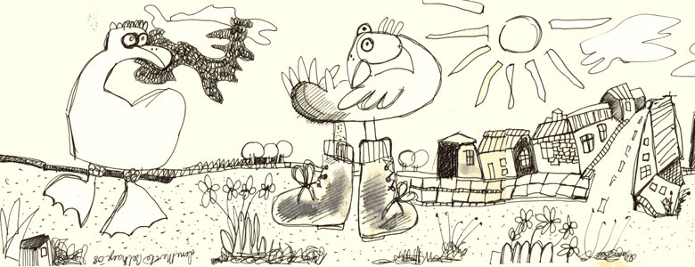
Invitation
to SUMMER PARTY AND ART SHOW
June 6th from kl.13 to 17
with Concert by Lilleskolens Jazzkapel
also guest Singer “Ruth BAnks “ kl 13.15
(8 man Jazz Band) kl 13.30-15.00
Doug Johnson poetry reading at kl 13
The Eyes of the Tiger"
"CARAVAN 4" in the "Tinghus Galleries"
the old jail house!! Still jail museum!!
Fredensborg , Tinghusvej 13
Exhibition is open every day June 5th to 10th
Kl 11 to 17 also week ends

Also meet the artists night
June 9th at 7.30 pm

Paintings, Watercolors, Sculpture. Ceramic
Silk,Photo, Graphics,Paper, Dressing dolls

"CARAVAN 4" the members of group are:
Faith Copeland, Annie Lund, Lone Merete Belhage,
Tanya Markul, Judi Holtze, Ruth Banks,Martin Bune
Susanne Kristiansson,Fie Rasmussen, Sanne Bitton Nielsen,Thomas Kristiansson

see more at www.faithcopeland.com/caravan4.htm
for more info write to faithcopeland@yahoo.com or call
tel 45 313854214

