upstairs  storage  toilet | 3  Sanne  Bitton Nielsen  akvareller PÅKLÆDNINGSDUKKER  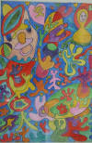 | 2  Thomas  Kristiansson  maleri  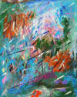 | 4  Susanne  Kristiansson  Maleri  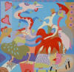 | 5.  Judi Holtze  Ceramic  Photo-portraits  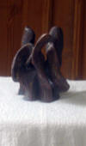 | 6  Ruth Banks  Glass maleri  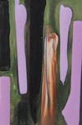 | 7  Annie Lund  Maleri  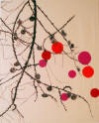
Down stairs  8  Faith Copeland  Mal;eri  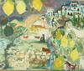 | 9,museum | 10.  MartinBune  maleri  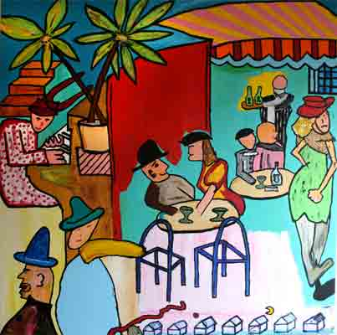 | 14  Faith Copeland  wall hangings  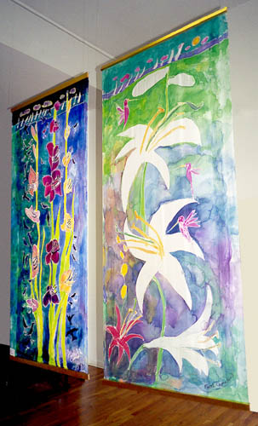  hall | 11  Tanya Markur  photography    digt | 12  Fie Rasmusen  Blomster og Portrætter  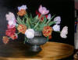 | 13  Lone Belhage  maleri  tegning ,graphic  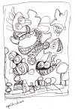
Main hall everyone represented

Locate the artist the upper row is upstairs
Lower row is downstair

